Assignment -4

|  |  |
| --- | --- |
| Assignment Date | 14 November 2022 |
| Student Name | POORANI S |
| Student Roll Number | AC19UIT033 |
| Maximum Marks | 2 Marks |

1. **Pull an Image from docker hub and run it in docker playground**

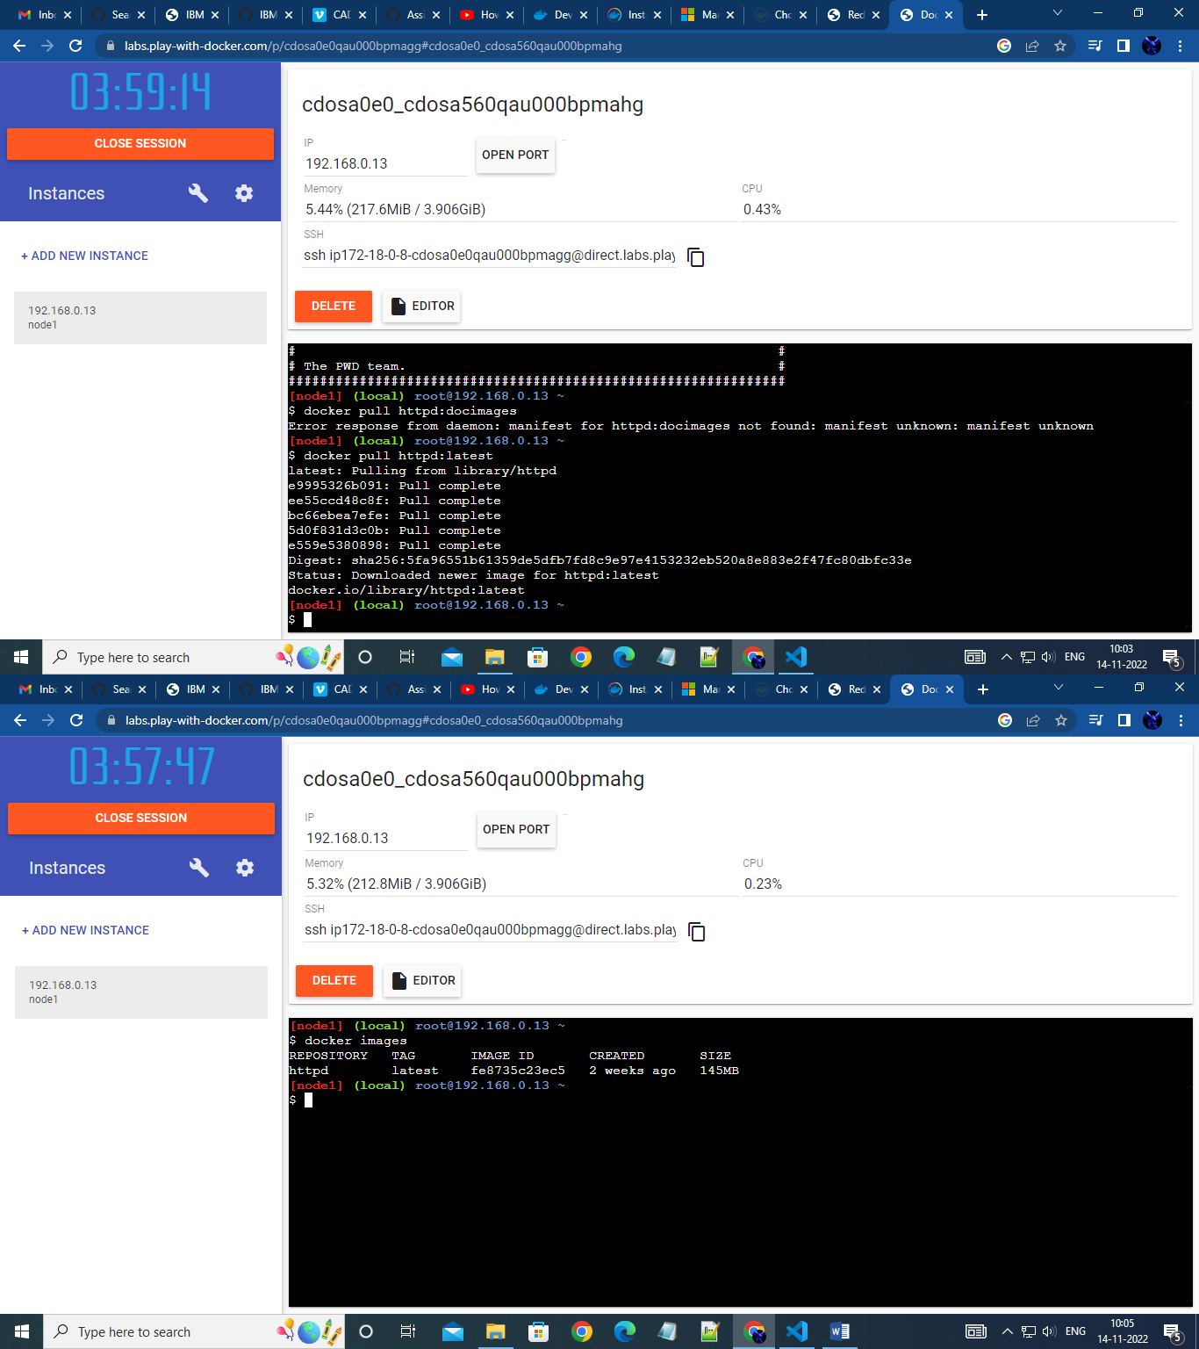

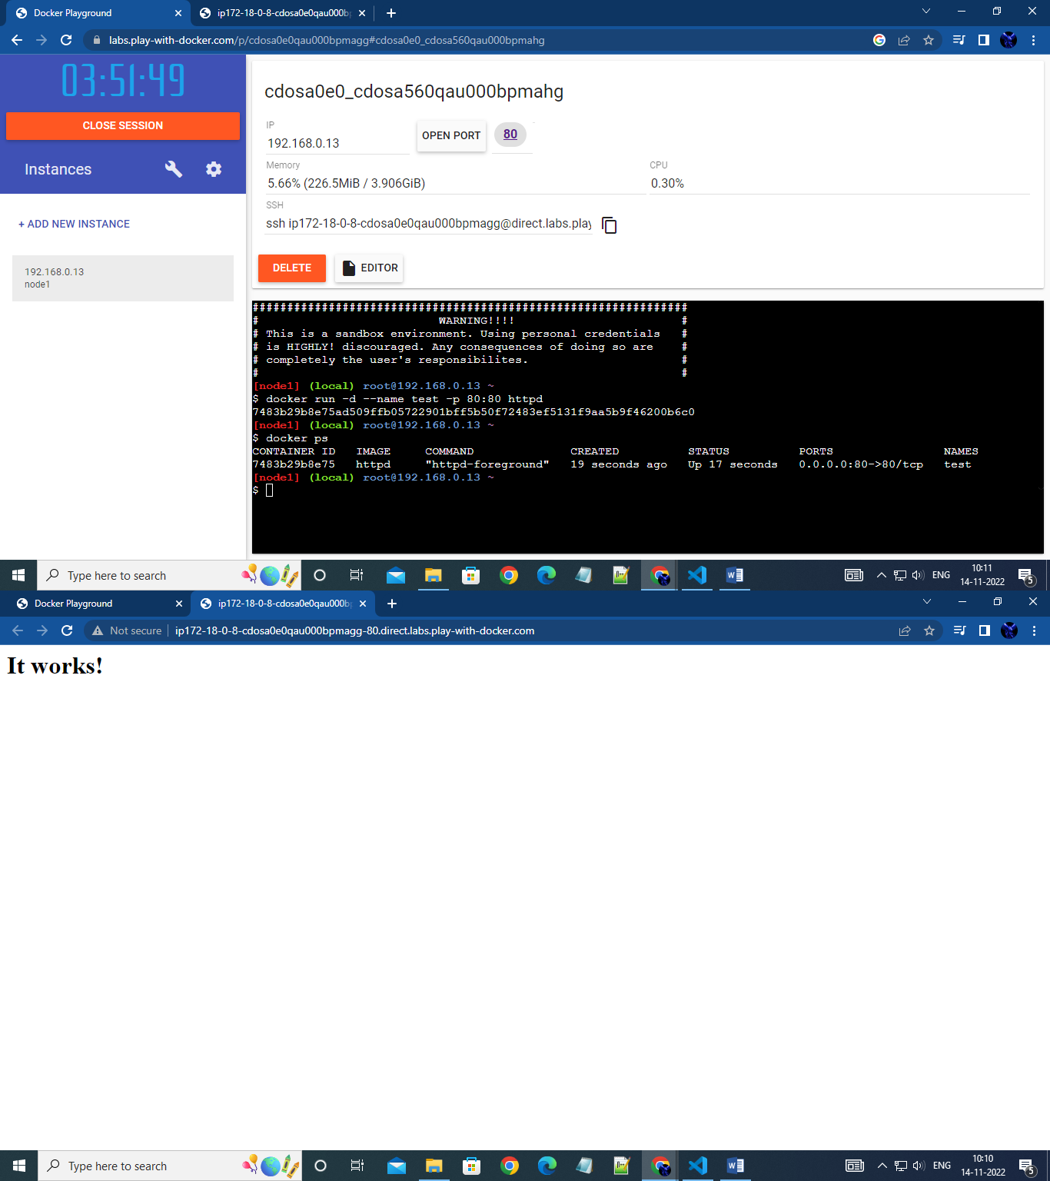

1. **Job portal application and deploy it in Docker desktop application.**

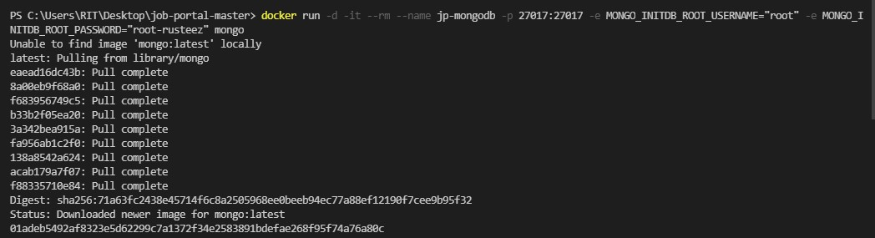

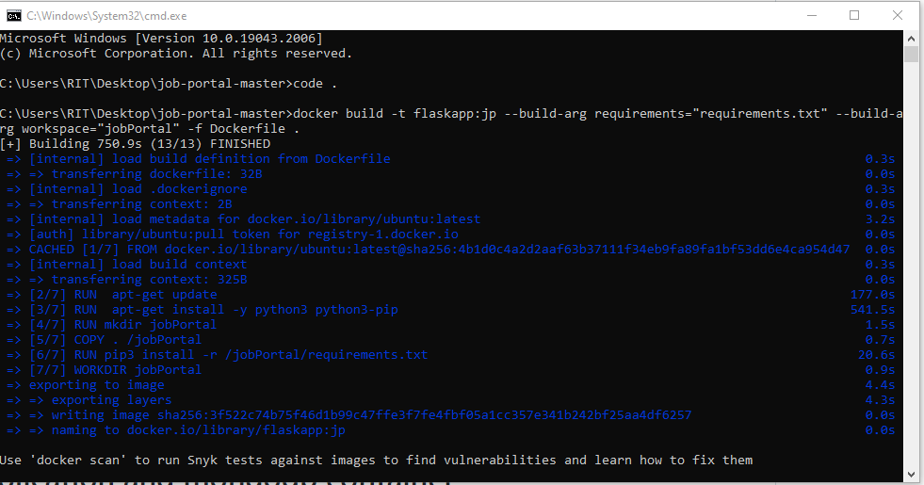

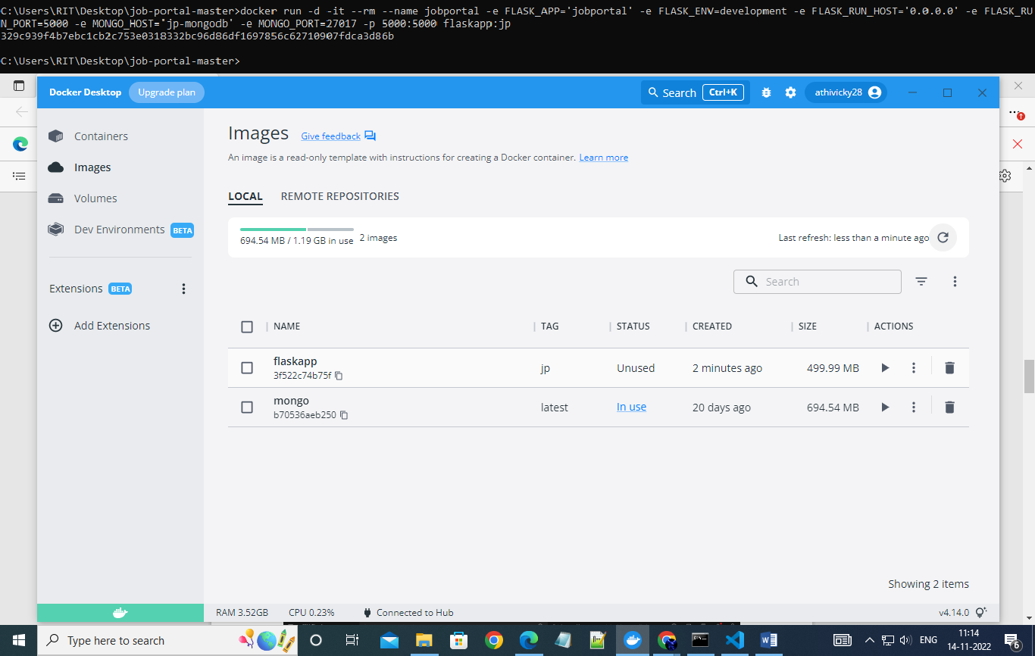

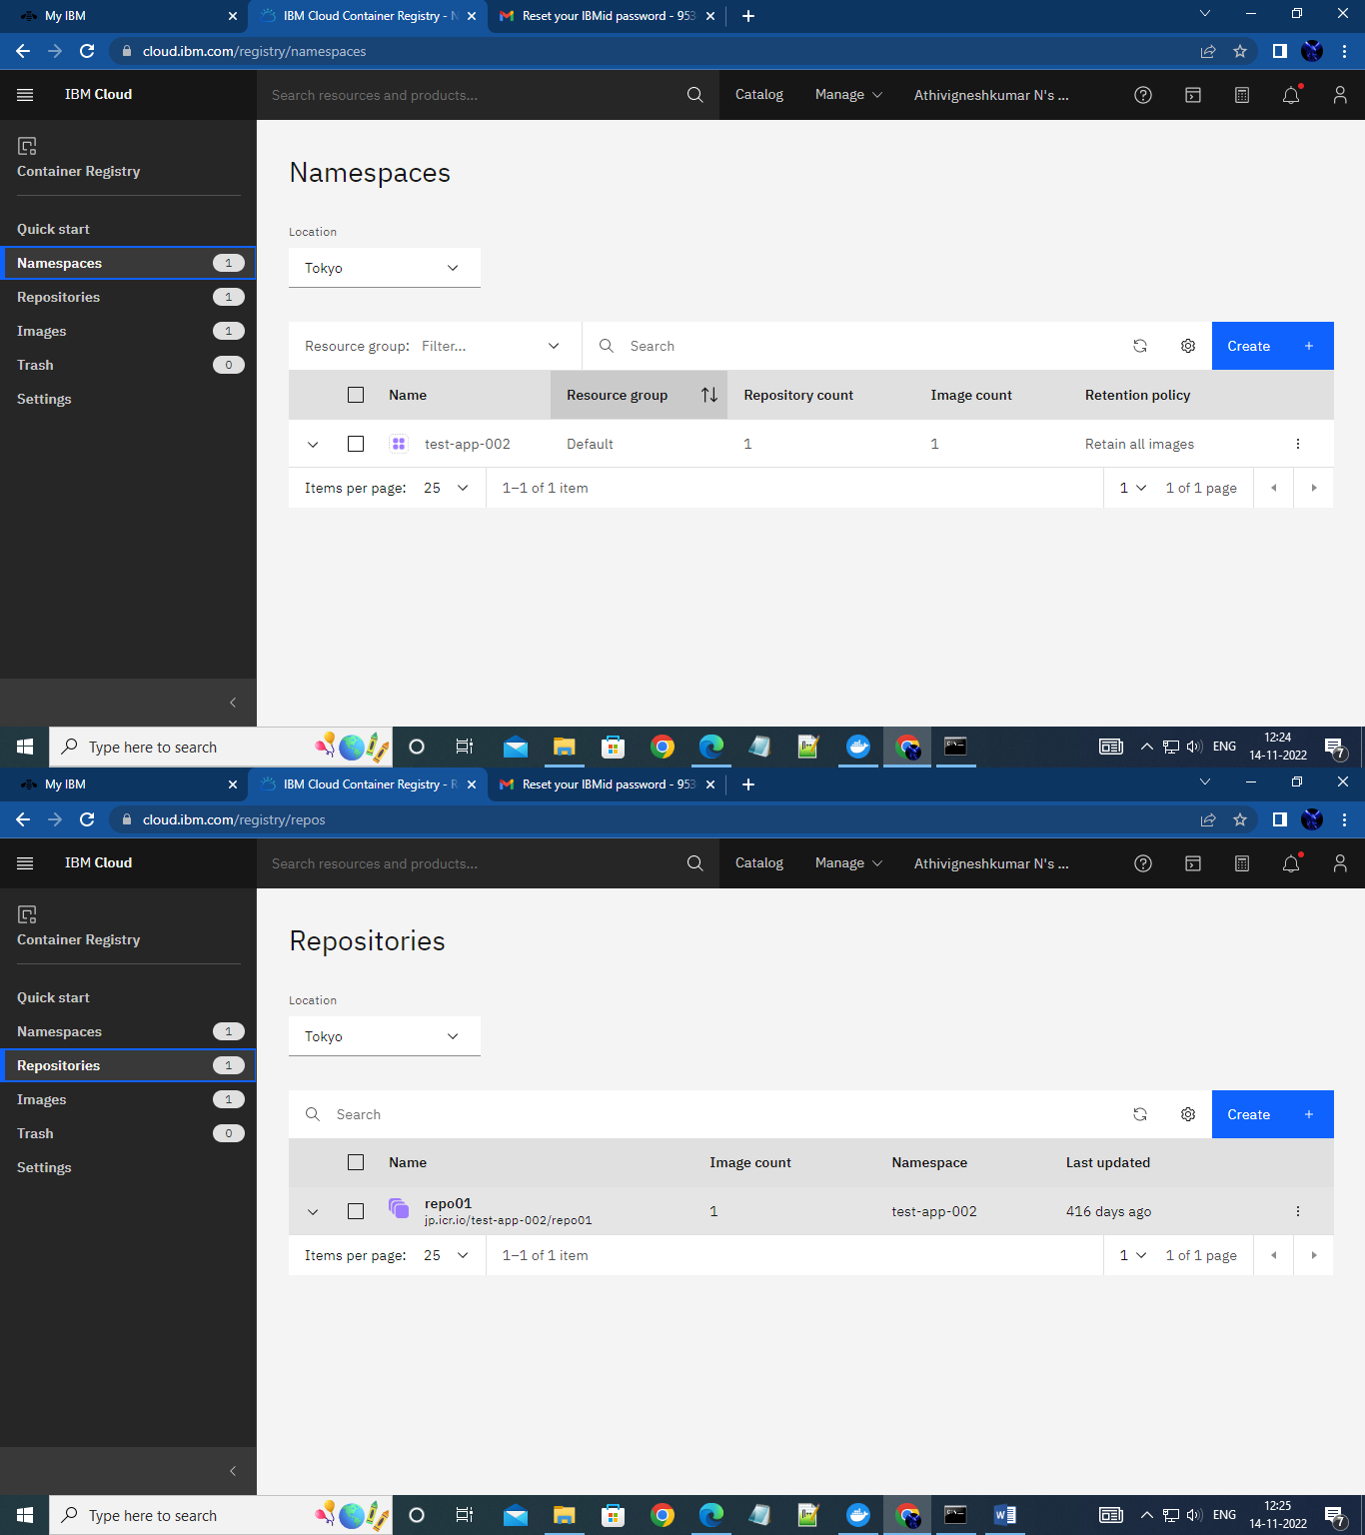3.Create a IBM container registry and deploy helloworld app or jobportalapp.

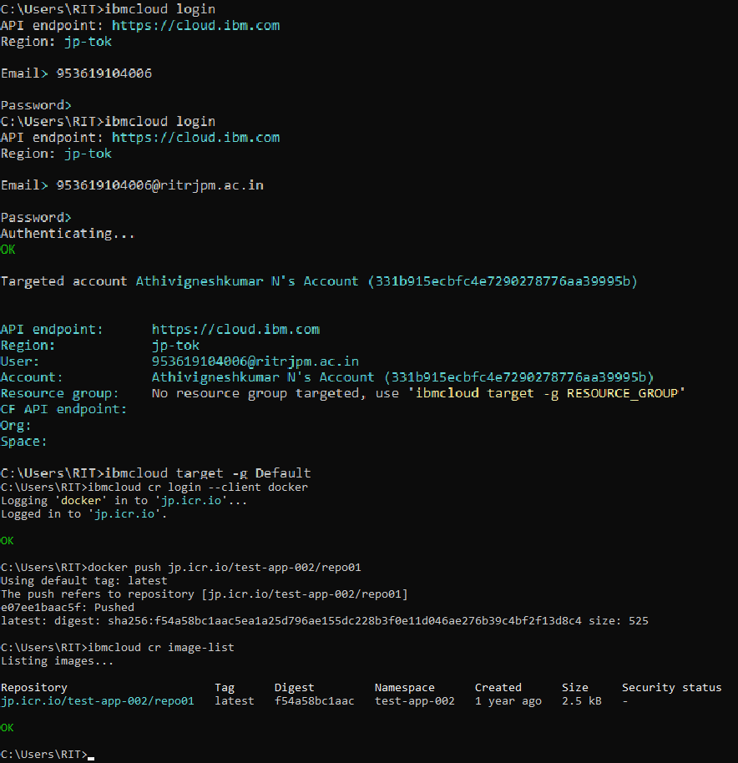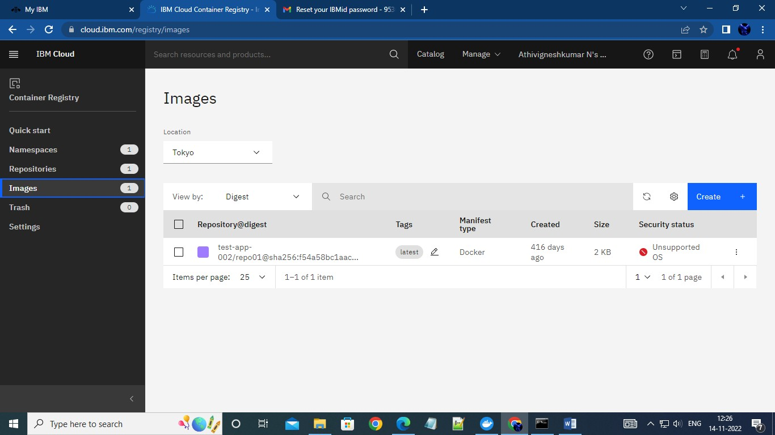

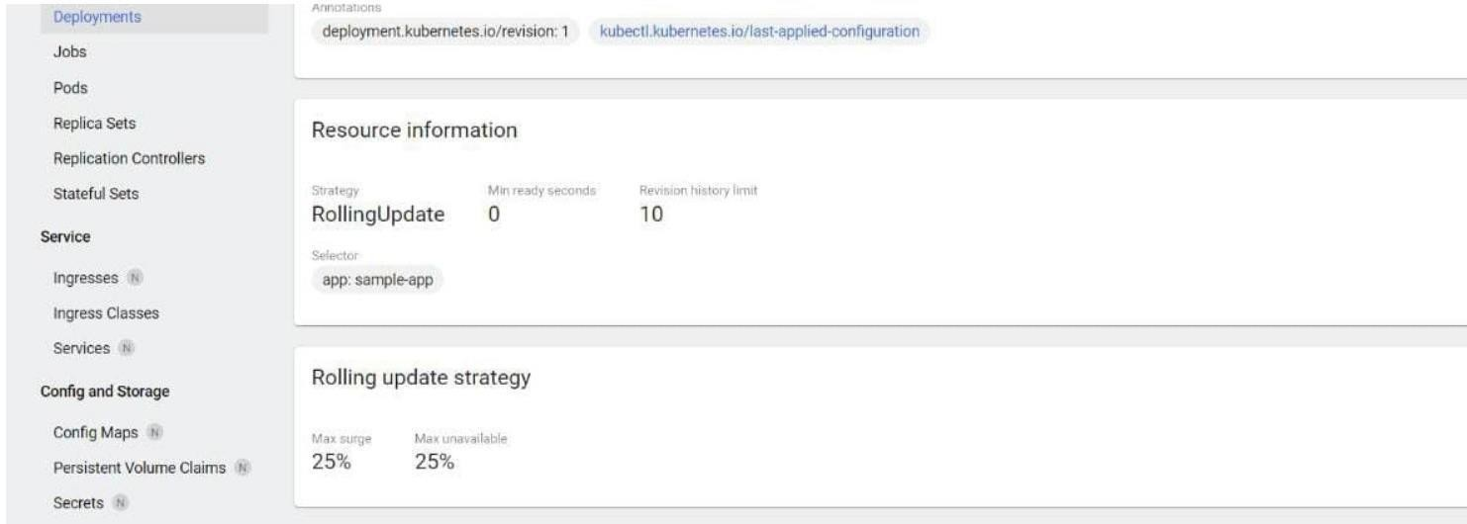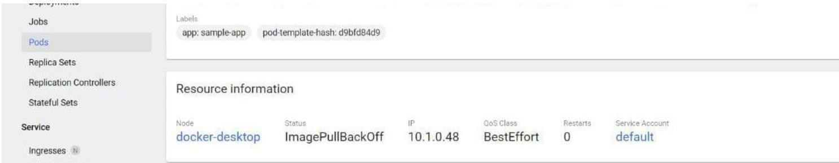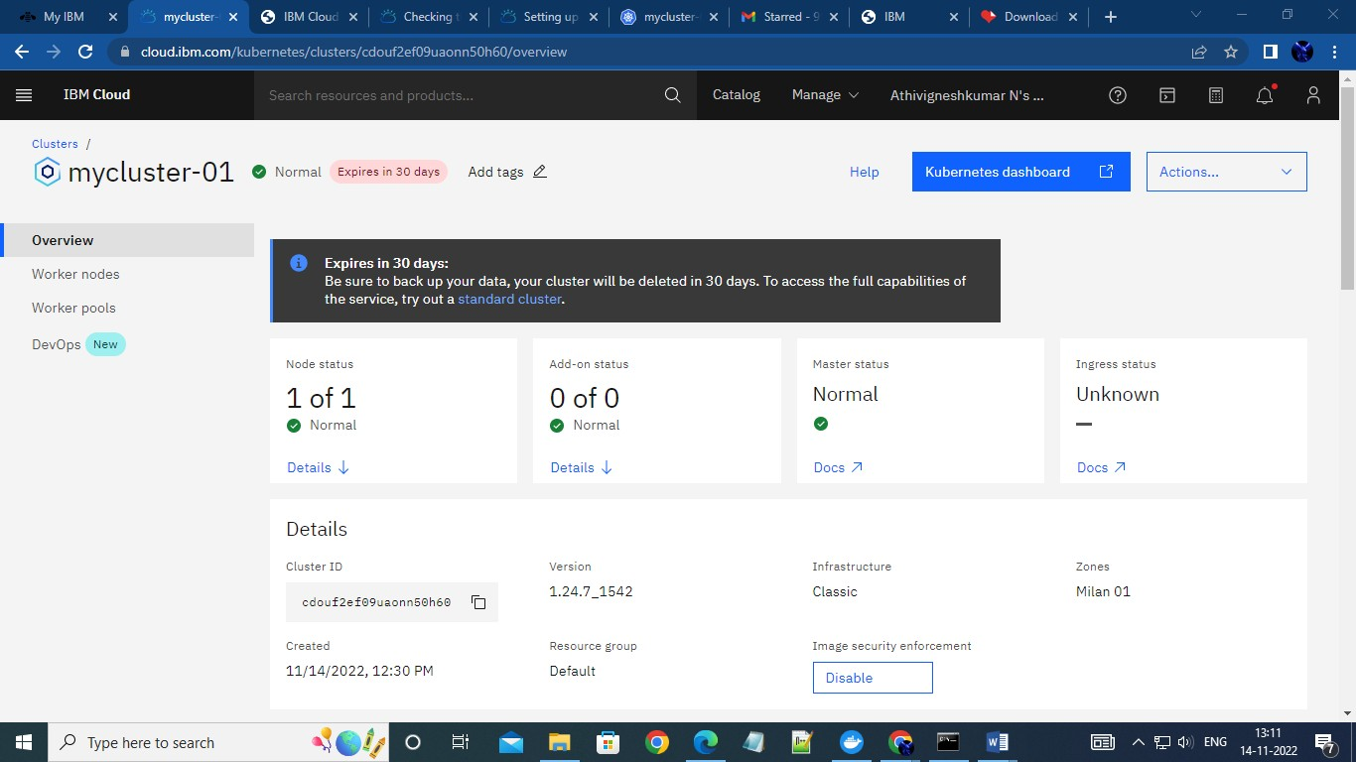4.Create a Kubernetes cluster in IBM cloud and deploy helloworld image or jobportal image and also expose the same app to run in node